Static Website Deployment
Amazon S3 (Simple Storage Service) is a scalable cloud storage solution provided by Amazon Web Services (AWS). It allows users to store and retrieve data from anywhere on the internet.
Using Amazon S3, developers can deploy static websites without the need for traditional web servers. It provides high availability, durability, and easy configuration, making it an efficient and cost-effective solution for hosting simple web applications and websites.
Objectives:-
- The objective of this assignment is to deploy a static website using cloud services and make it publicly accessible.
Step 1 : Create an S3 Bucket
Log into AWS Management Console. Navigate to Amazon S3 Click on Create Bucket Enter a unique bucket name (e.g., warisha--az). The name should be globally unique since it will be used for your website.
- Uncheck “Block all public access” (for public hosting)
- Create the bucket

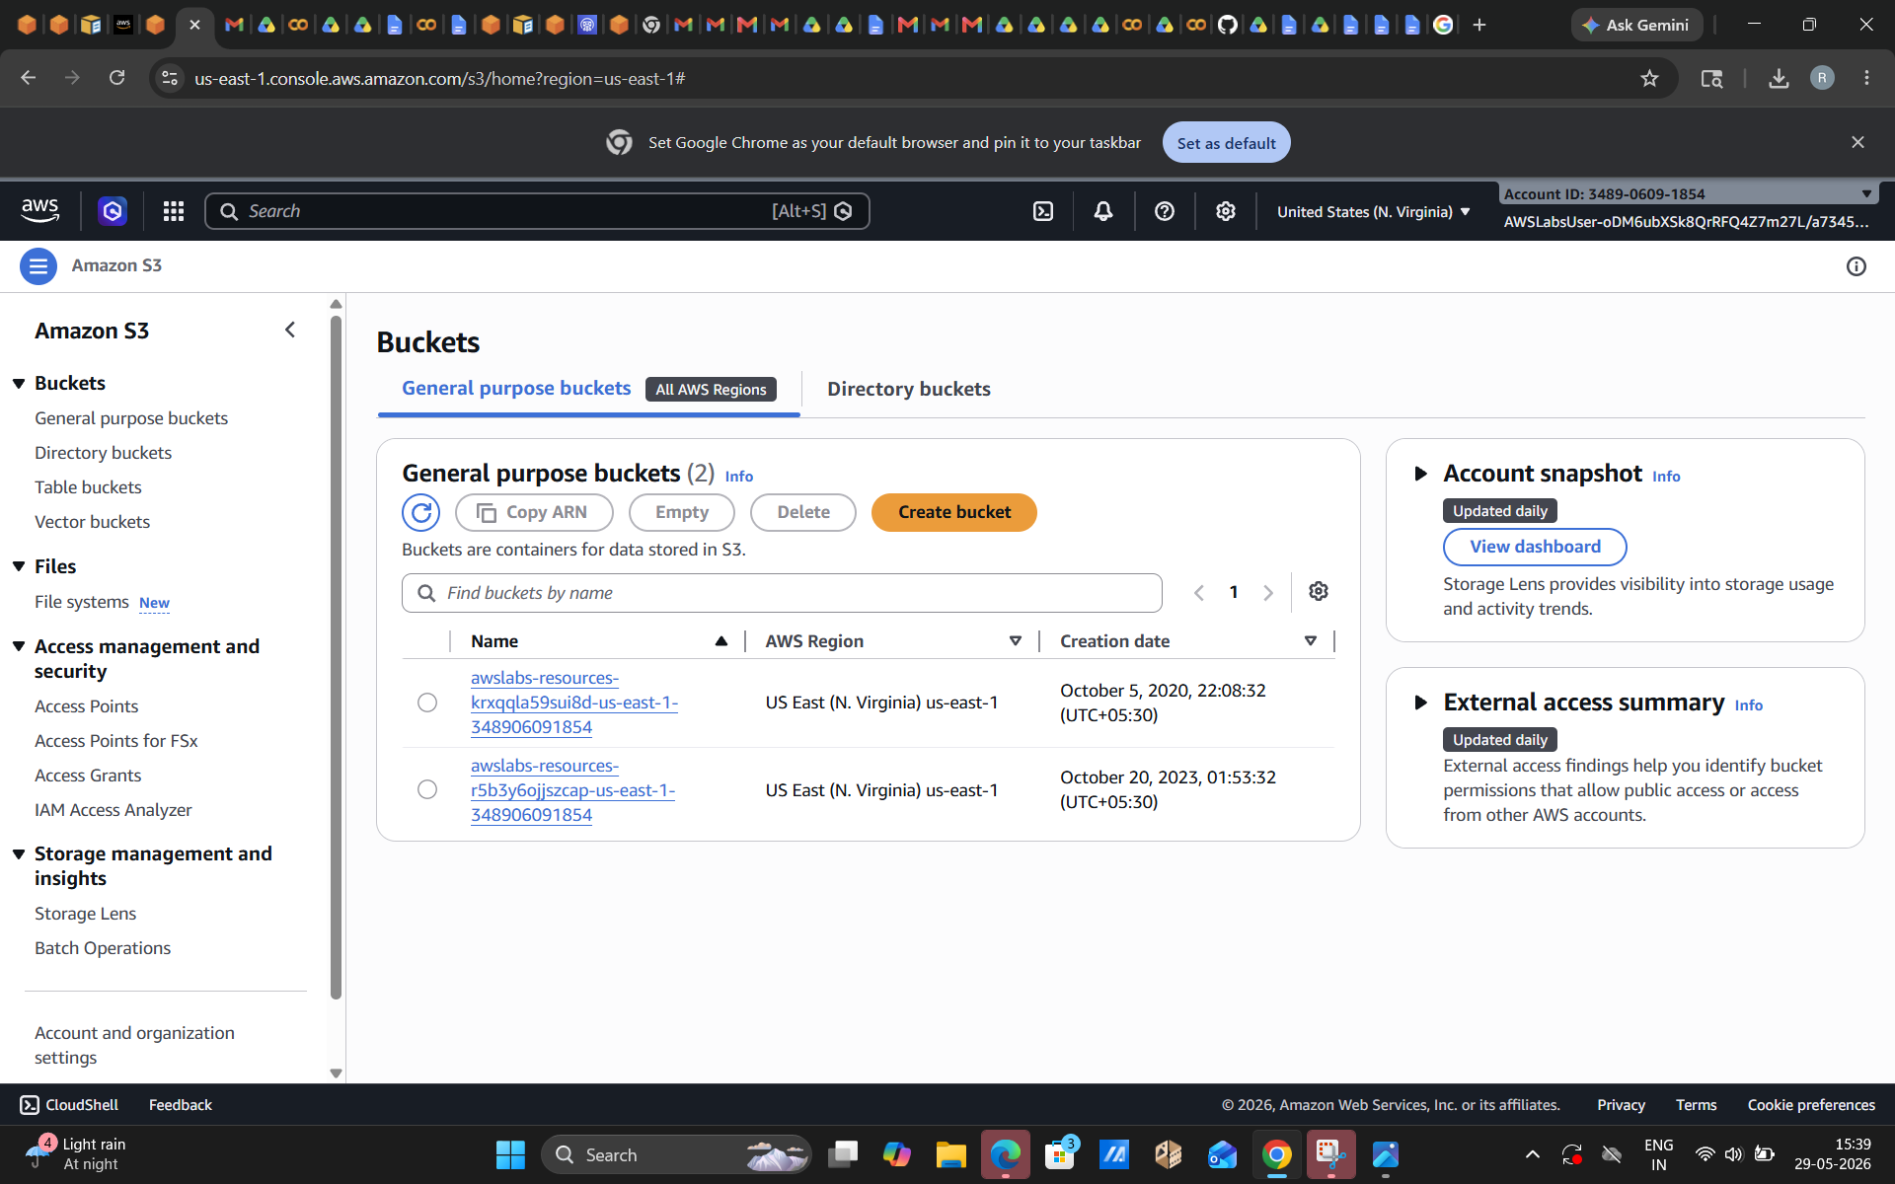

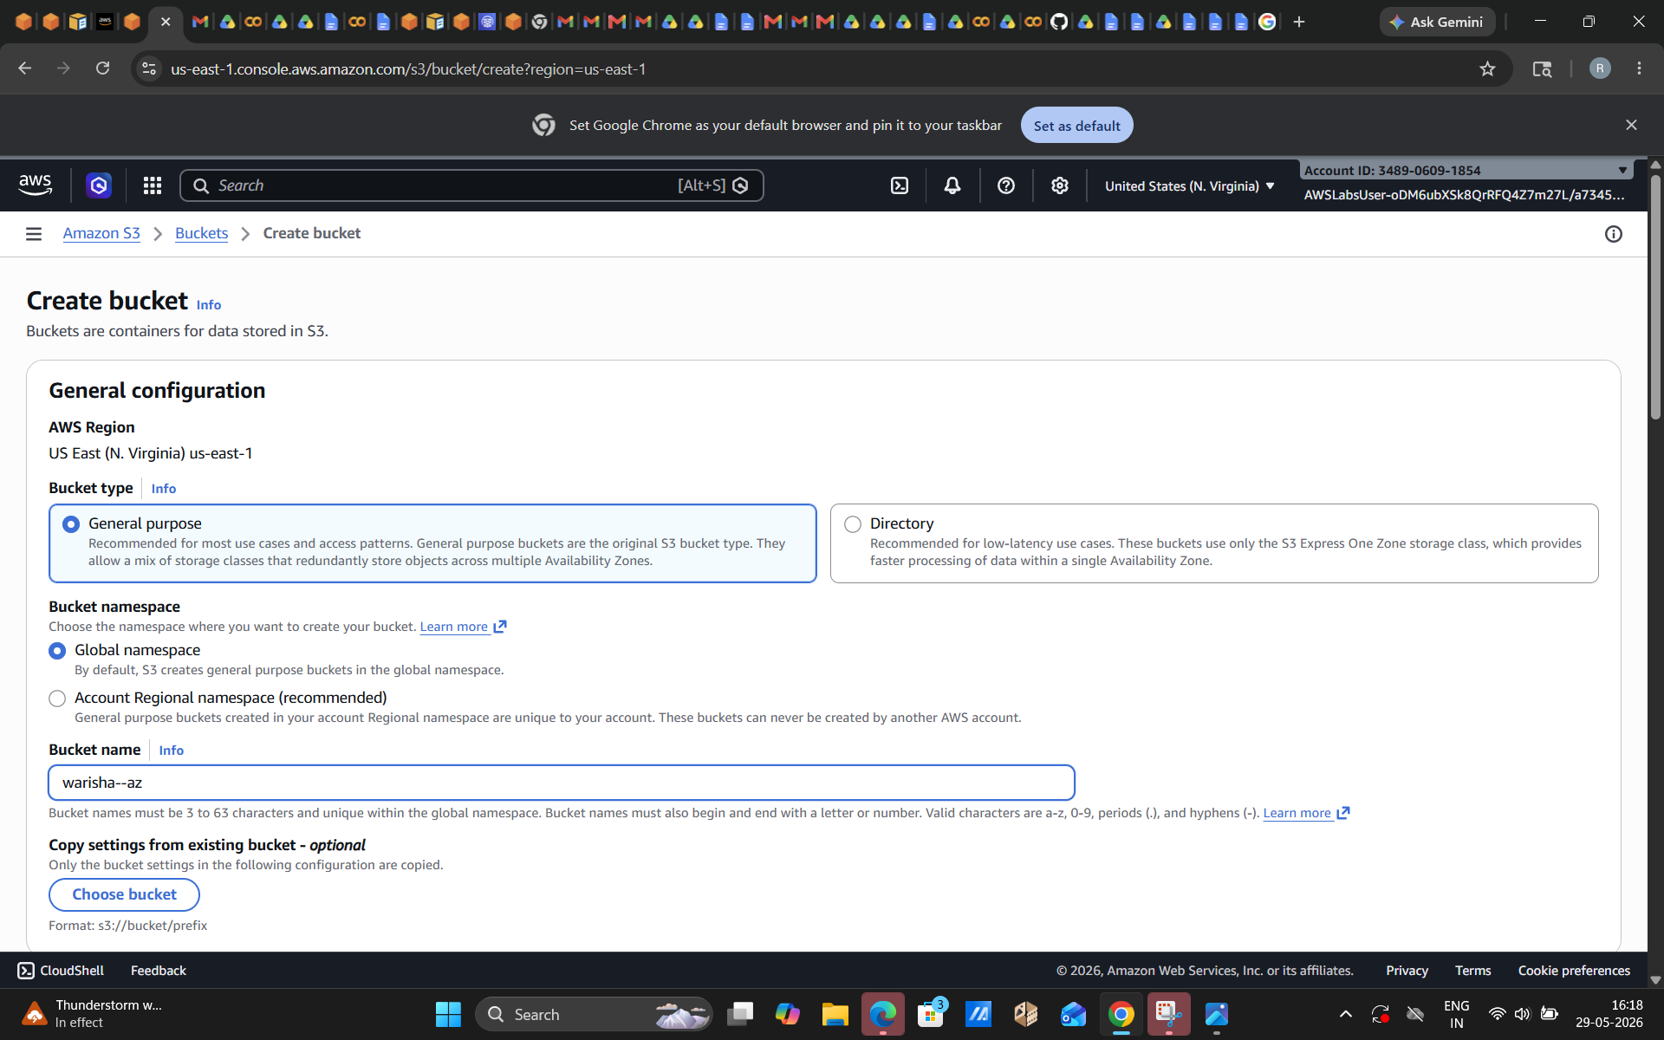

Step 2 : Setting up the Object Ownership
Select “ACLs (Access Control Lists) enabled”. This setting lets the bucket owner control access to individual files. It is useful when making specific files public for website hosting. Within this, the “Object Writer” setting is to be selected
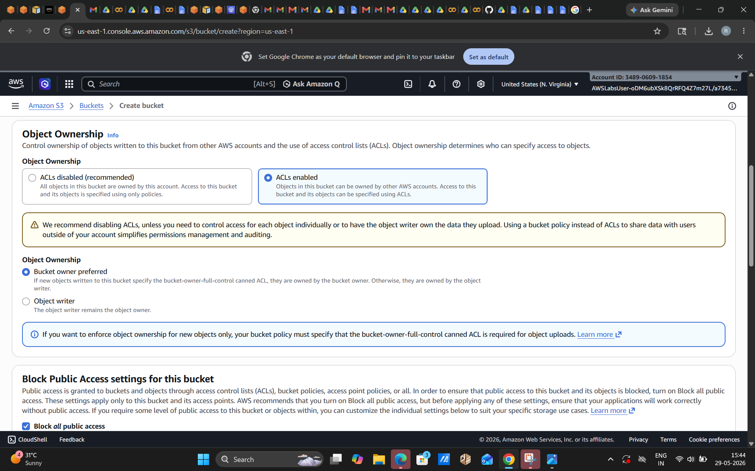

Step 3 : Block Public Access
By default, AWS blocks all public access for security. This option should be unchecked to allow the website to be accessible to everyone on the internet. Without disabling this, the website cannot be viewed publicly
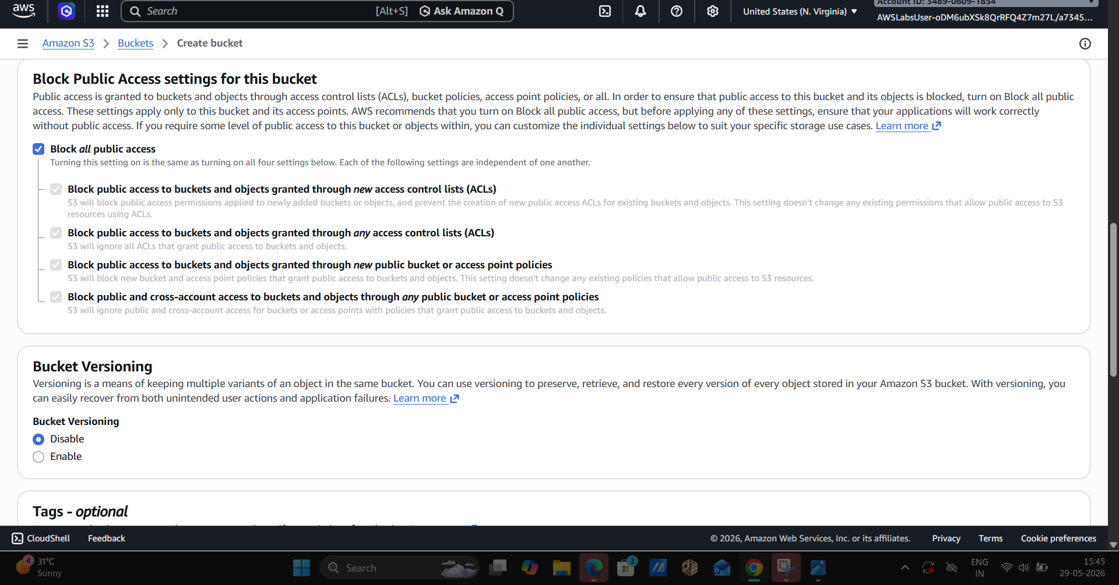

Step 4 : Default Encryption
This ensures that all data stored in the bucket is automatically encrypted.It improves security by protecting stored files without requiring manual encryption. Within this, Bucket Key should be enabled.

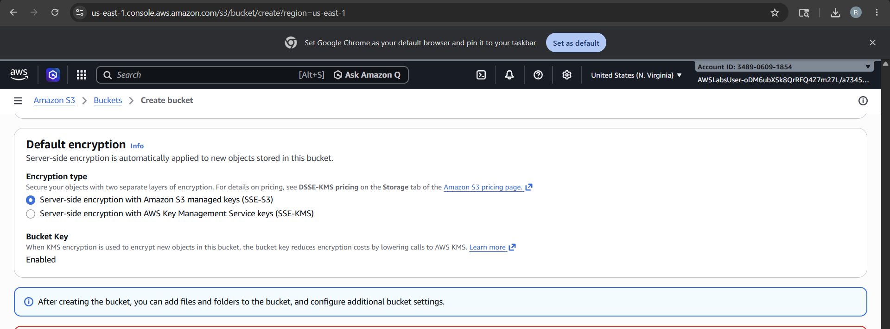

STEP 5:
Upload your website file in S3 bucket you created.
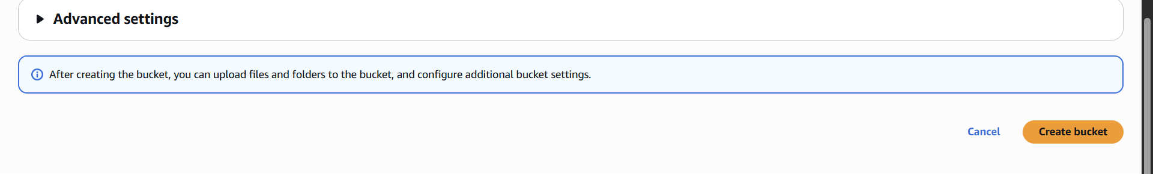

STEP 6:
Go to your S3 dashboard and select your bucket , actions>Make public using ACL . This will make your file public and anyone can open it using url. Confirm public access.

